**Spring 2024 CISC 3650 Group Project Website**

Group 3: Alizai Alina, Chen Danny, Liu Paul, Tariq Muhammad, Zakay Marsha

1. **Need Finding**

Goal/Big Idea:

To develop an application that will help Brooklyn College students to search for nearby restaurants that meet their desired criteria.

Core demographic / ‘Types’ of individuals:

Brooklyn College students, faculty, and other individuals close to the area.

No particular gender, age, role, or major. Individuals are expected to be located around the Brooklyn College campus and have some level of experience with technology to navigate webpages.

Plan for contextual inquiry:

Where: Brooklyn College Campus.  
When: Near common hours where most individuals are around campus and would be interested in finding suitable restaurants.  
How: Conduct a brief interview with willing participants.

Contextual inquiry observations:

Users identified – Three males, currently Brooklyn College students, during common hours seated outside. Users were asked ‘what they are getting for lunch’, followed by asking for a response on why they chose any particular choice. Afterwards, they are prompted to provide their opinion on other factors they may not have mentioned, such as cost, distance, food type, speed, and allergies.

Contextual inquiry was primarily conducted using a verbal interview process. Questions asked generally involved asking what the individual(s) would get for lunch, why they picked that choice (if provided), and what are their considerations when picking a place. If the individuals do not mention it themselves, they are prompted to provide their opinion on cost, distance, and dietary restrictions when choosing a restaurant. Findings include a majority of individuals are mostly concerned with restaurant price and distance from campus as their major decider. One individual raised concerns about common allergens and dietary restrictions, such as lactose intolerance.

Plan:

Three primary types of users were identified during contextual inquiry: cost concerned, distance concerned, and dietary concerned users. There may be some overlap between these users as each category is not exclusive to the others. Therefore, a website designed with the user’s concerns in mind should ideally offer customizable choices for restaurant pricing, distance from campus, and allow users to filter results based on dietary preferences or restrictions such as food allergies.

1. **Persona and Scenarios**

Personas and Scenarios

Target user base: Brooklyn College Students

User attributes:

1) Gender: All

2) Age: 18+ years

3) Level of experience: N/A

4) Interests/Goals: Dietary and financial considerations

Three demographic groups:

1) Price sensitive users:

Sample Name: Cameron Cost

Goal: To find the lowest cost offers.

Scenario: It is around lunchtime, and Cameron opens up their wallet and finds only a 10-dollar bill. They want to find places that will give them the most value for their money while also being within their price range.

- Emphasis on establishments that frequently offer deals/discounts.

2) Distance/Time concerned users:

Sample Name: Tony Time

Goal: To find the closest restaurants.

Scenario: Tony was attending office hours with a professor and now only has 20 minutes to get and eat their lunch before their next class. They want to find a restaurant close by to get their lunch at.

- Concerned with travel time to and from the establishment, including wait/preparation time at the restaurant.

3) Dietary restricted/ingredient concerned users:

Sample Name: Daniel Diet

Goal: To find restaurants that align with dietary choices/restrictions.

Scenario: Daniel is picky about their food, and they want to explore some vegetarian options but are unsure about which restaurants nearby offer them.

- Concerned with ingredients due to health-related concerns (allergies and intolerances), and self-imposed dietary choices.

1. **Storyboard Lab and Prototype**

Design Process: The website is intended for Brooklyn College students to discover or narrow down restaurant options based on some user-defined criteria. These criteria include sorting by pricing, the location’s distance from campus, and food options based on dietary considerations and restrictions. This is an important project as most students are around or on campus during common afternoon hours, and they will likely be interested in food options nearby that match their preferences.

Prototype Link: https://www.figma.com/proto/1cw4R1S6dfG90v3VUhW2SF/Untitled?node-id=1-231&mode=design&t=bjDGKeBPl5jL3tDs-1

Storyboard:

Wireframe 1:

Wireframe 2:

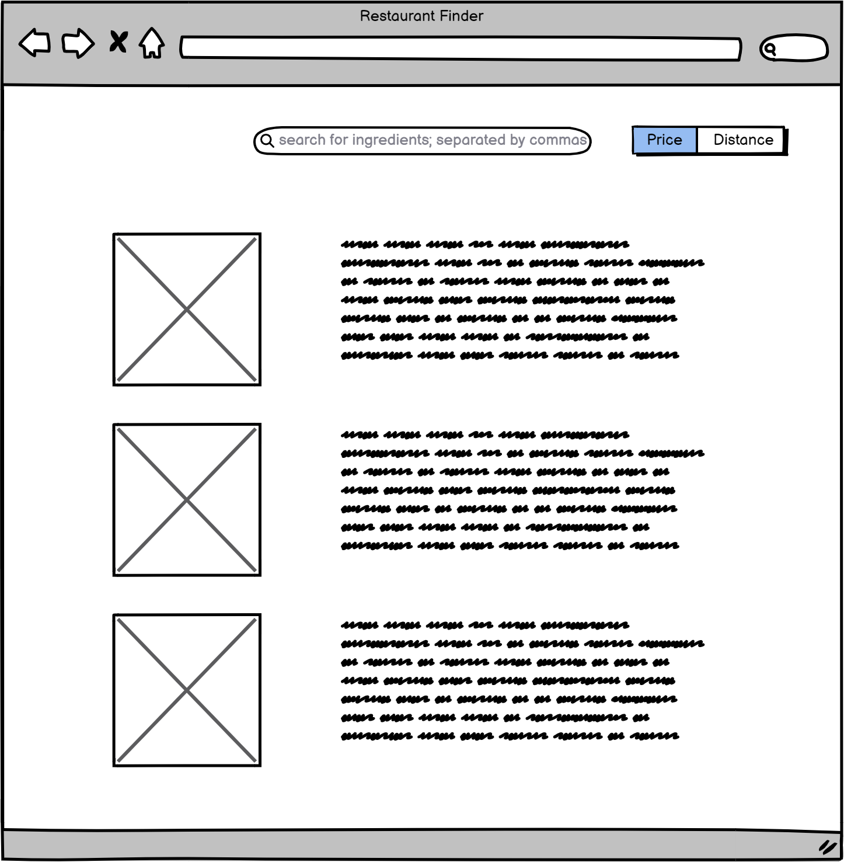

Wireframe 3:

For the webpage, the available filter options was discussed as they will primarily affect the end result of the application. We mutually agreed that some of the most important options in filtering suitable restaurants would be price, distance, and dietary restrictions. All are important options to be considered as they can be considered hard restrictions (affordability, time to travel/receive an order, as well as restrictions such as allergies). The available options for these categories should be constrained within reasonable limits and should be simple to understand and interact with. With this design style in mind, the option selectors and results would ideally be displayed on the same page to enhance the user experience, with the results being displayed in a clear and concise way. This may include features such as relevant pictures, a brief description, and a clear and simple display of pertinent information such as the address.

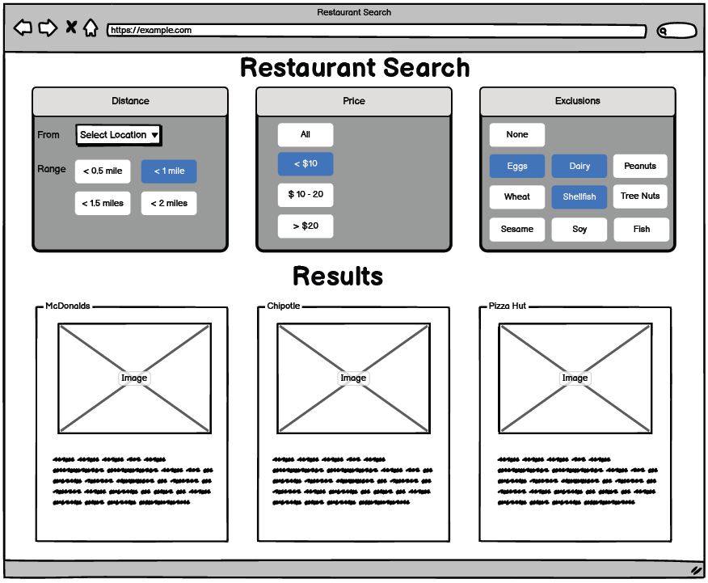

Wireframe 4:

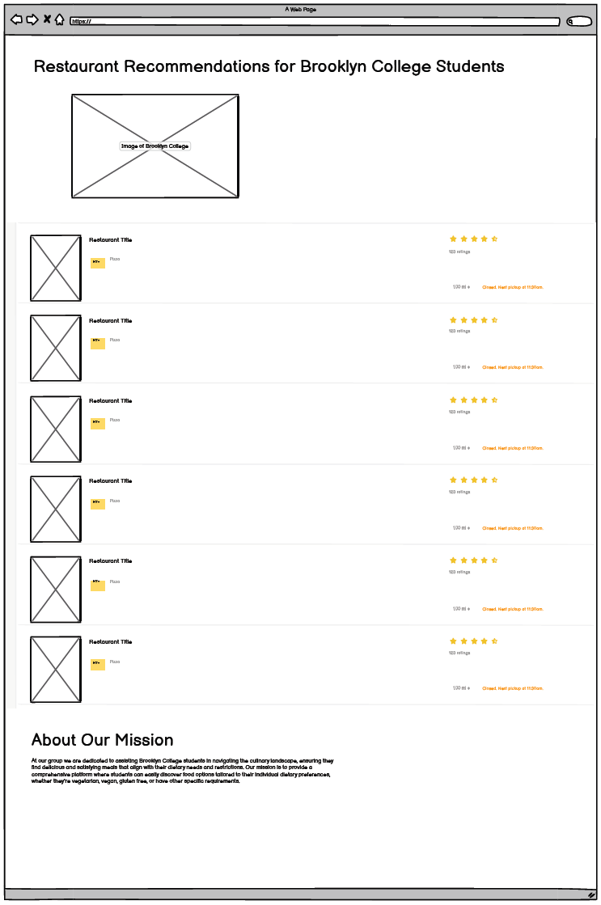

Wireframe 5:

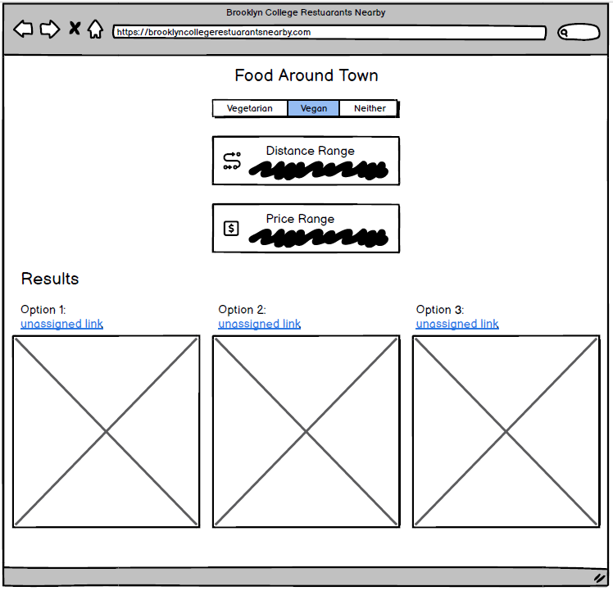

Wireframe 6:

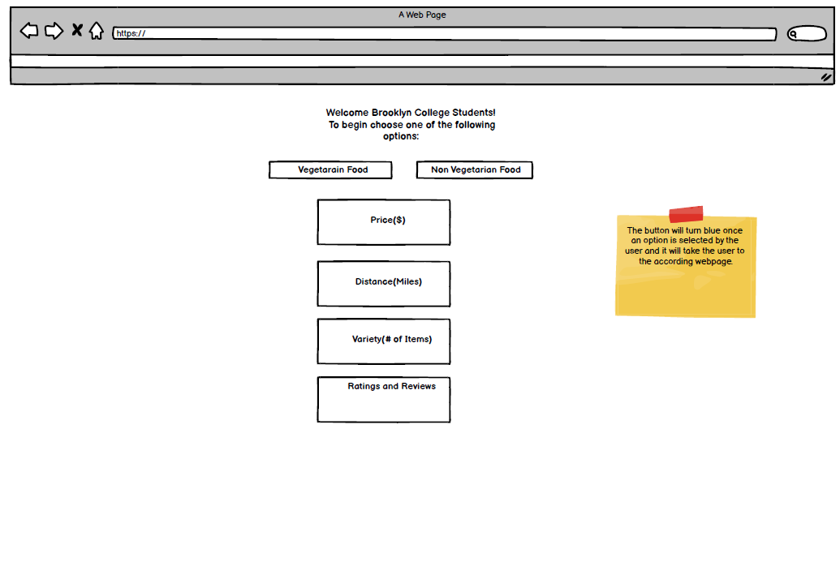

Discussion:

For the webpage, the available filter options were discussed as they will primarily affect the result of the application. We mutually agreed that some of the most important options in filtering suitable restaurants would be price, distance, and dietary restrictions. All are important options to be considered as they can be considered hard restrictions (affordability, time to travel/receive an order, as well as restrictions such as allergies). The available options for these categories should be constrained within reasonable limits and should be simple to understand and interact with. With this design style in mind, the option selectors and results would ideally be displayed on the same page to enhance the user experience, with the results being displayed concisely. This may include features such as relevant pictures, a brief description, and a clear and simple display of pertinent information such as the address.

1. **A brief description of what each member contributed.**

Danny - Needfinding Lab, Persona and Scenario Lab, Wireframe (#3), Figma prototype, Search webpage and elements (search.html / base.css / main.js).

Paul - Persona and Scenario Lab, 2 Wireframes (#1, #2), drew the Storyboard

Alina – Wireframe (#4), Home Page webpage (index.html / style.css)

Marsha – Wireframe (#5)

Muhammad – Wireframe (# 6)

1. **Sources**

**For search.html / main.js**Bootstrap 5.3:  
 1) Bootstrap responsive containers:  
 https://getbootstrap.com/docs/5.3/layout/containers/  
 2) Bootstrap grid layout with predefined classes:  
 https://getbootstrap.com/docs/5.3/layout/grid/  
 3) Bootstrap column for alignment and spacing:  
 https://getbootstrap.com/docs/5.3/layout/columns/  
 4) Bootstrap gutters & spacing classes  
 https://getbootstrap.com/docs/5.3/layout/gutters/  
 https://getbootstrap.com/docs/5.3/utilities/spacing/  
 5) Bootstrap container border classes  
 https://getbootstrap.com/docs/5.3/utilities/borders/  
 6) Bootstrap toggle buttons functions  
 https://getbootstrap.com/docs/5.3/components/buttons/  
 7) Bootstrap cards layout and styles  
 https://getbootstrap.com/docs/5.3/components/card/  
  
Mozilla JavaScript references  
 1) For each loop  
 https://developer.mozilla.org/enUS/docs/Web/JavaScript/Reference/Global_Objects/Array/forEach  
  
W3schools JavaScript references  
 1) EventListener documentation  
 https://www.w3schools.com/jsref/met_element_addeventlistener.asp  
 2) Event targeting (get calling object)  
 https://www.w3schools.com/jsref/event_target.asp